322COM Reflective report

For my coursework I have been given the task of creating a real-time ray tracer using C++. To accomplish this task I chose to use the SDL library as it allows for easy manipulation of the pixels on screen, as well as methods for receiving user input.

I used multiple resources to help build up my application, with my main starting point being [this article](https://www.programmersranch.com/2014/02/sdl2-pixel-drawing.html). I chose to base my code from this example because it uses an SDL Texture, as opposed to an SDL Surface. SDL Textures are new to SDL2, and are superior to surfaces as discussed in [this SDL to SDL2 migration guide](https://wiki.libsdl.org/MigrationGuide):

Figure 1 - SDL Migration Guide

While the performance difference for an application such as mine may be minor, I still wanted to use all the tricks I could to get the best performance from my ray tracer.

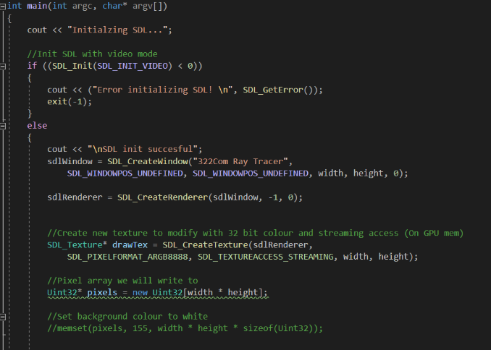Creating an SDL context was simple enough, and it didn’t take long for me to add a sphere class and draw a basic shape to the screen.

Figure 3 - The starting point for my Ray Tracer

Figure 2 - Code for creating an SDL window and texture I can draw to

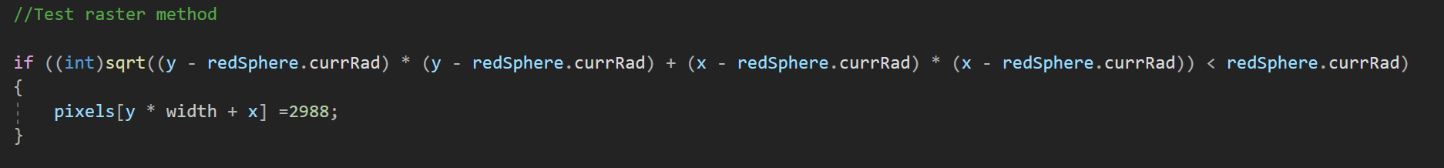

Figure 3A - Simple code I wrote for drawing a circle

My next step was to implement a ray-sphere intersection method, which will allow me to cast a ray from each pixel of the sphere, and see if it hits my sphere based on its origin, direction and the spheres radius/position.

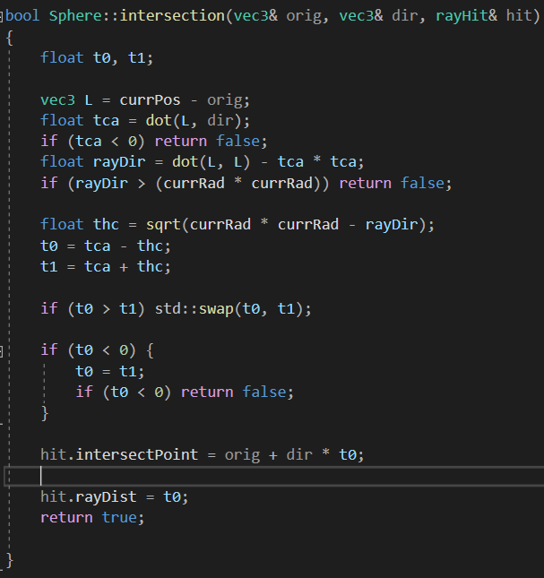This code is based on the Geometric solution, which allows us to reject the ray early by comparing if the ray direction is greater than the sphere’s radius. The downside to this is that it forces us to calculate the square root of the ray direction, so instead of computing this value I check if the ray direction squared is greater than the radius squared.

The square root operation is very costly so it should be avoided wherever possible.

After computing the intersection I save the intersection point and the ray distance/t value to a ray struct I pass in for later use.

Figure 4 - Sphere intersection code

This code doesn’t contain any logic for sorting depth, so I added it in my main drawing loop:   
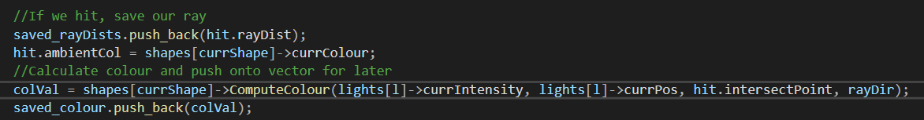

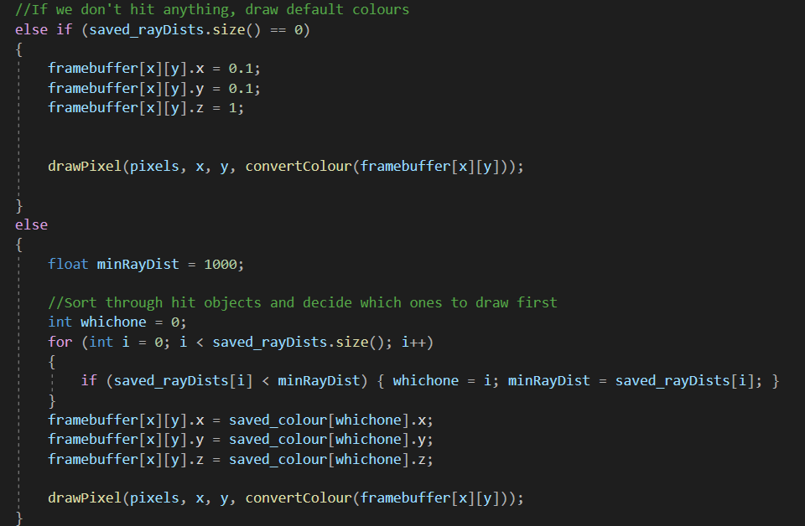Figure 5 - When a shape is hit, I save the ray intersection distance, calculate the colour and then save it to a vector

At the end of the for loop I run through the vector of saved ray distances (t values). If there are none (We didn’t hit anything), then I draw the default background colour, otherwise I sort through the distances and decide which one to draw first.

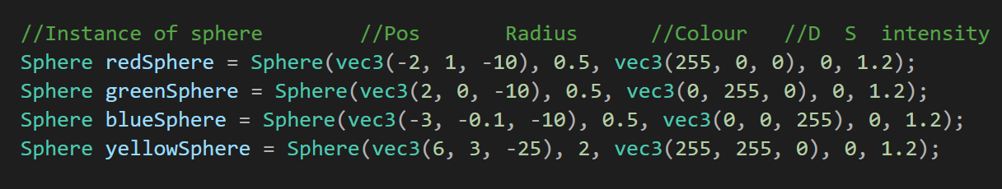

Figure 6 - Multiple instances of my sphere class

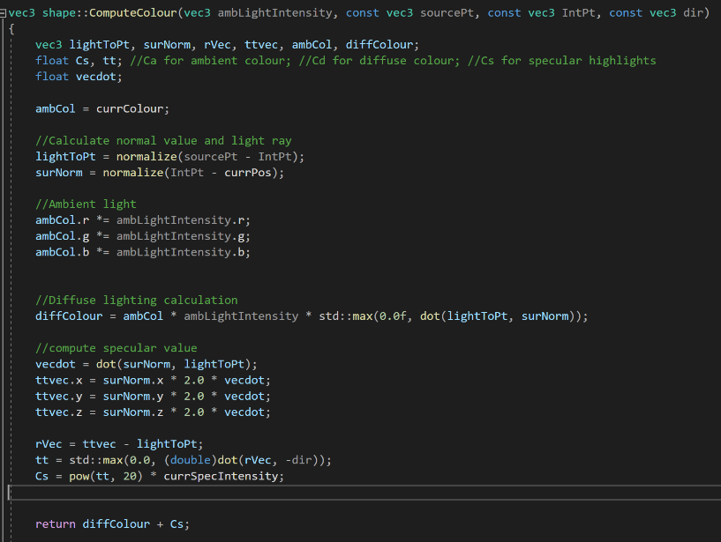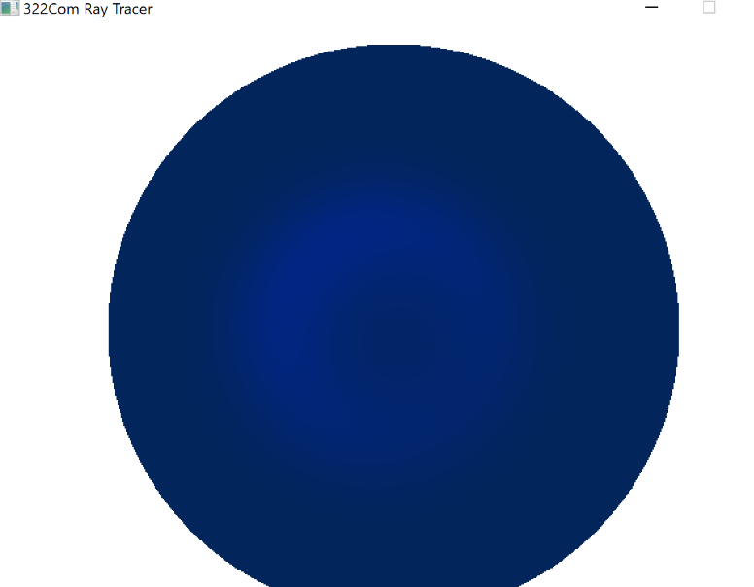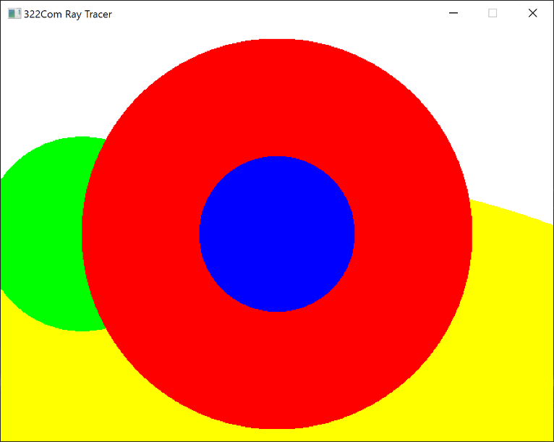I was able to add multiple spheres at varying depths and have them be drawn correctly.

Figure 7 - My updated function that returns a vec3 RGB value

Figure 8 - My first attempt at computing the colour

Figure 9 - Depth sorting working

My next task was to add diffuse, specular and ambient lighting. Ambient lighting is simple as it just involves adding a value to the shapes base colour. Diffuse and specular are a little more complicated, but I was able to implement them easily enough by looking at their equations:

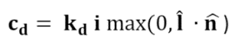

Figure 10 - Diffuse lighting equation

Figure 11 - Specular Lighting Equation

My first attempt at adding lighting didn’t go to plan. The function I used to compute the colour returned the final colour value as one integer, whereas the rest of my code uses a vec3. I initially tried converting the colour to a vec3 (Which produced the result shown below), but in the end I decided to re-write the function so that it returned an RGB colour value.

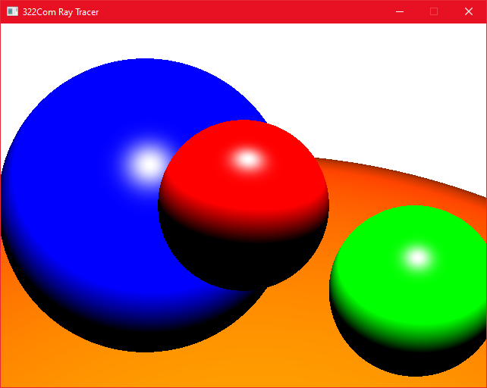With this updated function the colours/lighting work perfectly, letting me move onto adding more primitives.

Figure 12 - Specular and diffuse lighting

I wanted to add a plane as this would also let me add shadows to my project. To define a plane, you need a function that accepts a point on the plane and then a normal value.

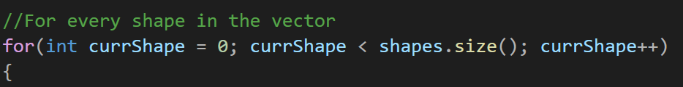Just like my sphere intersection method, I needed to pass in the origin and direction of my main ray. To keep things simple I decided to split my shapes into classes. I created a base class called Shape, which has virtual functions for computing the intersection and the colour, and then my subclasses such as Plane and Sphere inherit from Shape and override these virtual functions. I am then able to create instances of these shapes in the main method and push them back to a vector of shapes, which I then run through in my loop for each pixel.

Figure 13 - Iterating through each shape

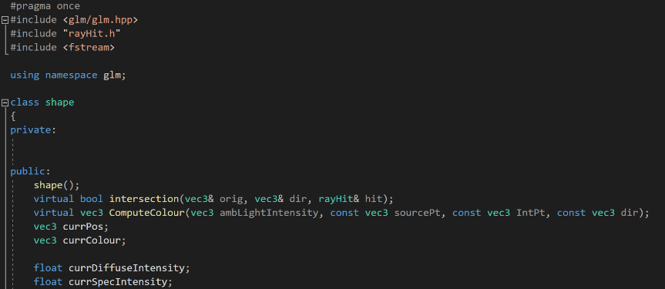I had to make sure my vector was a vector of pointers, otherwise only the base class functions would be called, rather than the overrides.

This object-oriented design makes it easy to add new shapes to my program. I was able to make a plane class, and override the base intersection function with the following code:

Figure 14 - My shape class

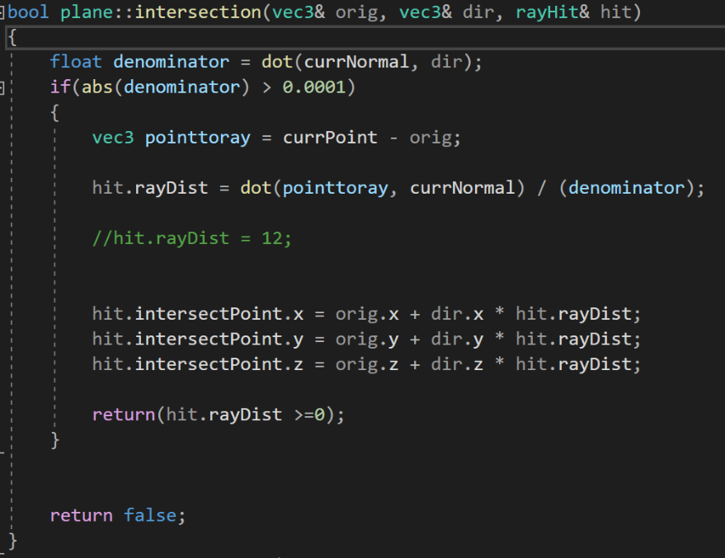If the denominator is close to 0, the plane and the ray either perfectly coincide (Resulting in an infinity of solutions), or the ray is away from the plane which gives us no intersection. This means we return false if the denominator is less than a small value (0.0001 in my example).

If the ray does intersect then I calculate the distance and point of intersection, like in my sphere class, before saving it to the ray struct I pass in.

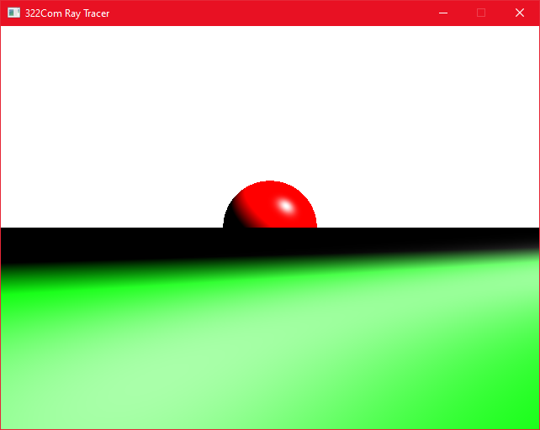My initial attempt at adding the plane was somewhat broken:

Figure 15A - The broken plane

It took me a little while to fix this, but the problem turned out to be that I had misread the formula, and I was mistakenly using the ray direction value in my calculation of the ray distance when I should have been using the normal value.

This was causing the incorrect value to be returned and therefore meant my depth sorting code was drawing it in-front of the spheres rather than behind.



Figure 16 - my mistake

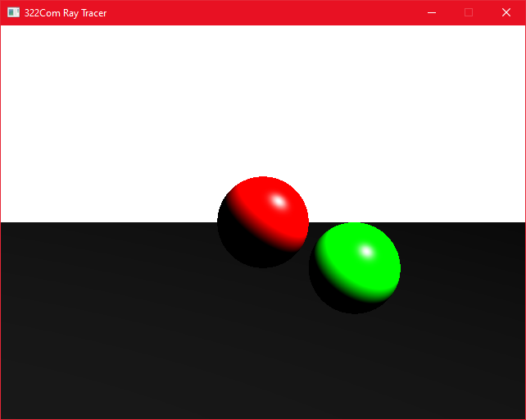After correcting my mistake my plane looked like this:

Figure 17 - The plane now draws correctly

The next thing I needed to add were shadows. These are calculated by waiting until we intersecting with a shape, and then running through each shape again but this time running the intersection check with the original intersection point as the origin, and the opposite direction to our light source as the direction. If these secondary “shadow rays” hit anything, we then set that colour to black to show that it’s in shadow.

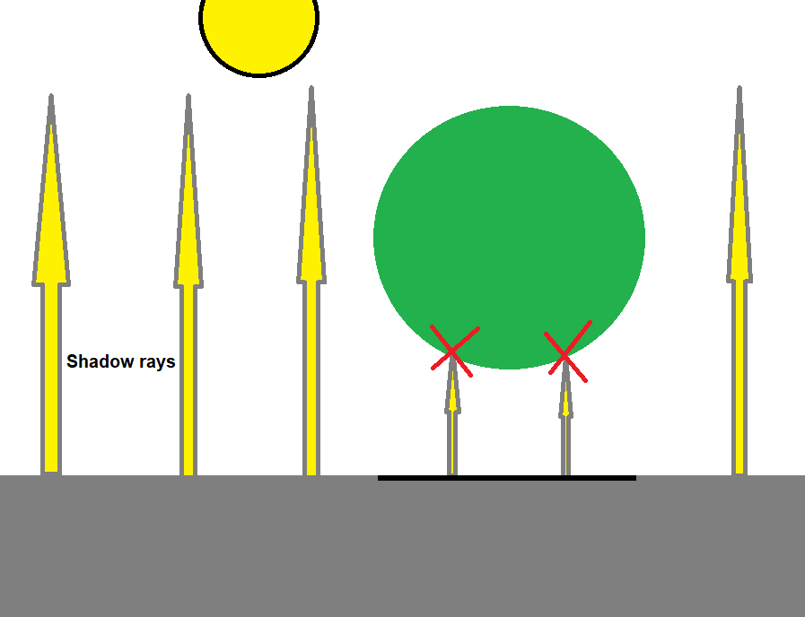

Figure 18 - Diagram showing shadow calculation

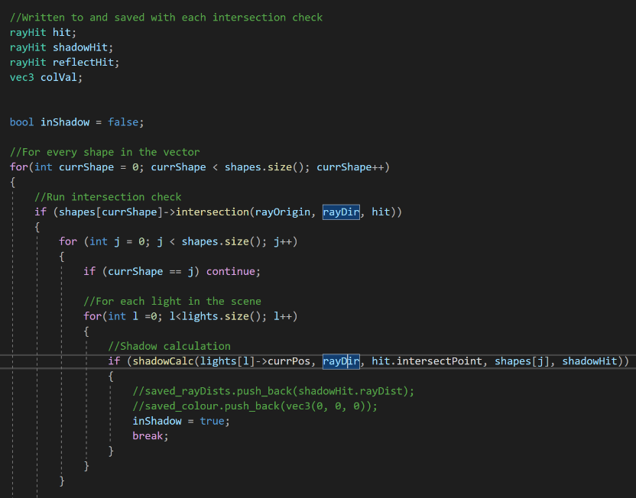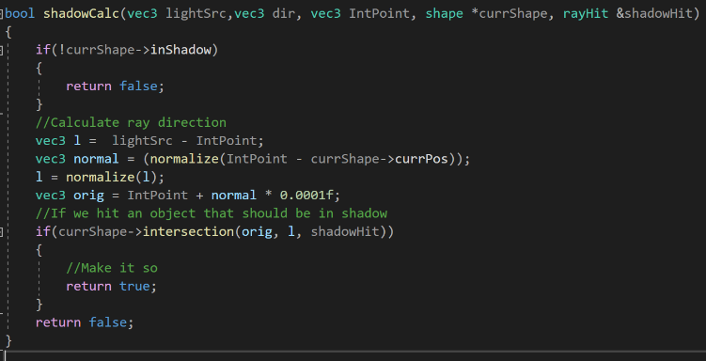I have implemented the above logic into my code. I start by running the same intersection check for each shape, but now when there is an intersection the code goes through each shape again, firing a ray from the original intersection point. The shadowcalc function called in this section can be seen below:

Figure 19 - I run through the shape array twice to calculate the shadows

Figure 20 - The shadow calculation function

I am reusing the same intersection function for each shape, just with different arguments. If there is a shadow intersection, we break out of the nested loop and set the current pixels colour to black:

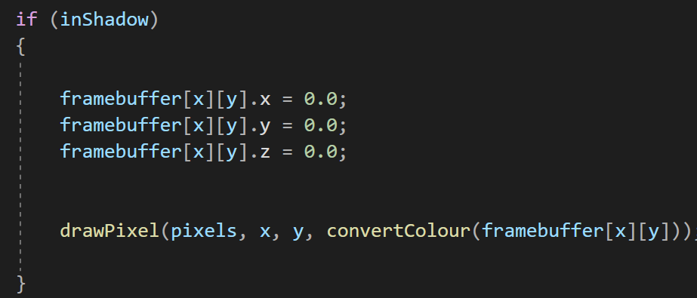  
  
Otherwise, the pixel is coloured as normal:

Figure 21 - If an object is in shadow its pixels are set to black

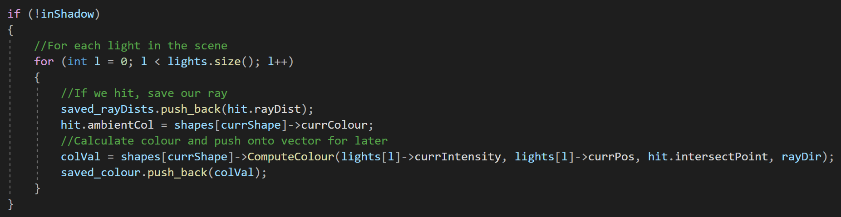

Figure 22 - Otherwise it is calculated normally

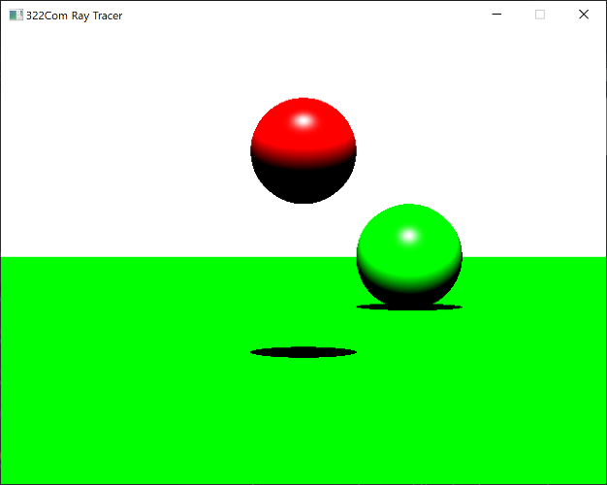

Figure 23 - Working hard shadows

The result from this code is that my shadows are now drawn correctly on the plane.

The next thing I added was a triangle class. Triangles are used to build up more complex meshes, so having a functioning triangle is essential.

I initially chose to use the geometric solution for calculating ray-triangle intersection, but I ended up switching to the Moller Trumbore solution for reasons I will discuss later on.

I found the mathematics behind ray triangle intersection confusing, so I used [scratchapixel.com](https://www.scratchapixel.com/lessons/3d-basic-rendering/ray-tracing-rendering-a-triangle/ray-triangle-intersection-geometric-solution) to help me understand the equations and implement them into code. My first attempt at rendering a triangle looked like this:

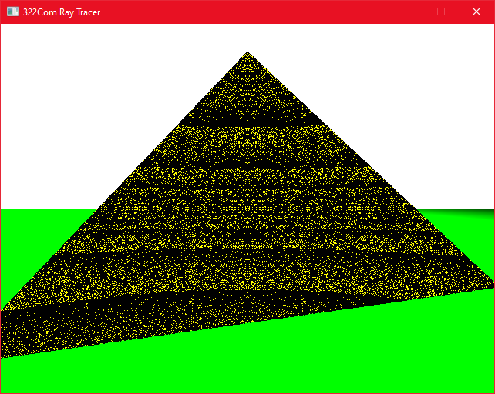I discovered that I needed to work out the barycentric coordinates (U,V and W) to correctly interpolate colours across the triangles face.

The three coordinates must add up to a total of 1 to be valid. By adjusting these coordinates you are adjusting the divide between colours across the face of the triangle.

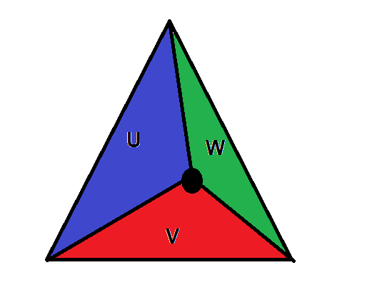

Figure 24 - Without barycentric coordinates my triangle did not render correctly

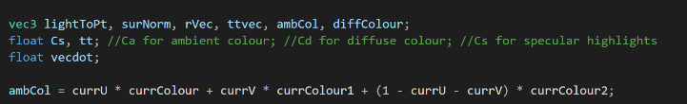So to fix the broken colours, I had to add a U and V argument into my triangle constructor (W can be calculated from U and V), and then modify the computeColour function to use these values to calculate the ambient colour value:

Figure 25 - Barycentric coordinates example

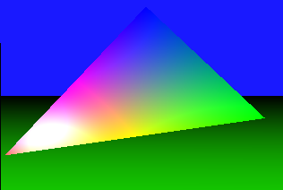This solved the colour problem with my triangle. I was having an issue where my triangle wasn’t drawing shadows, so I switched to the Moller Trumbore solution which did solve my problem, but naturally when it came to take a screenshot for this report, they stopped working.

Figure 26 - Using U, V and W in my calculations

From my understanding however the Moller Trumbore method is superior and more versatile, so it wasn’t a complete waste of time.

Now my triangle class was functional, I moved onto importing OBJ files. I had access to a simple OBJ loader, although I had to modify it somewhat as it was originally written with OpenGl in mind. The loader returns a vector of vertices, which I should then be able to reconstruct into triangles by looking through and making a triangle with each group of three vertices.

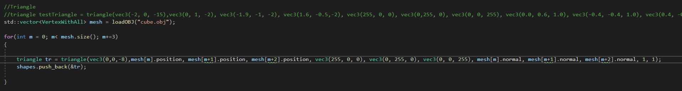

Figure 27 - The original code I wrote to load OBJs

In theory this should have all worked perfectly, except any OBJ I loaded looked like this:

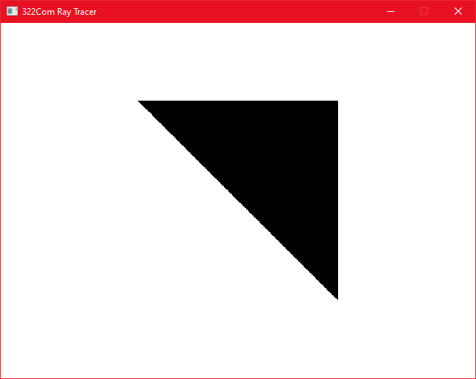The code would show one triangle and nothing else. What confused me the most was that the vector of shapes had the correct amount of triangles in it, and I could draw as many triangles and other primitives as I wanted to.

Figure 28 - Broken OBJ loading

I even tried using a different OBJ loading library, tinyOBJ, which gave me the same results.

For simplicities sake I went back to the original one I was using, but I still was none the wiser to what was causing this problem.

After a lot of confusion, I finally found the source of the problem – I was pushing back a reference to a triangle, which I had been doing for all the other shapes but in this case it mattered because it meant I was just filling my shapes vector with a bunch of pointers to the same triangle.

The fix for this was to just load all the triangles into their own vector, and *then* load those triangles by reference into my shapes vector.

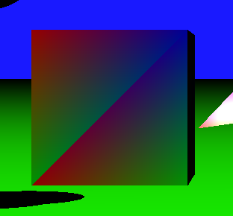My last two additions were multiple light sources and user interaction.

Figure 29 - Successfully loading an OBJ

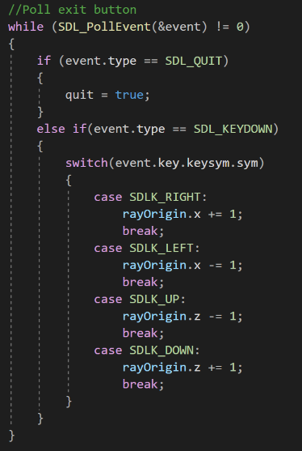Interaction was as simple as using SDL to poll for keydown events, and then adjusting the rayOrigin accordingly:

Figure 30 - Camera movement code

Multiple light sources were achieved by creating a light class which holds an intensity and a position. I then created a vector of lights that I loop through for each intersection where I calculate colour.

All I had to do from here was add some instances of lights to my vector and the lighting is drawn accordingly:

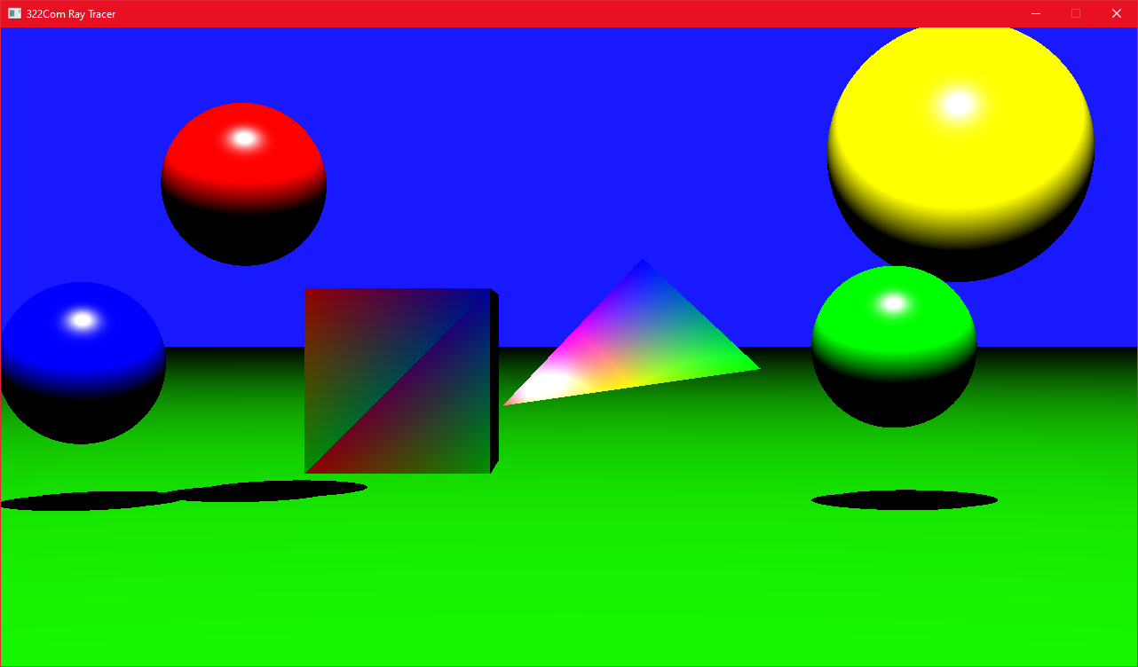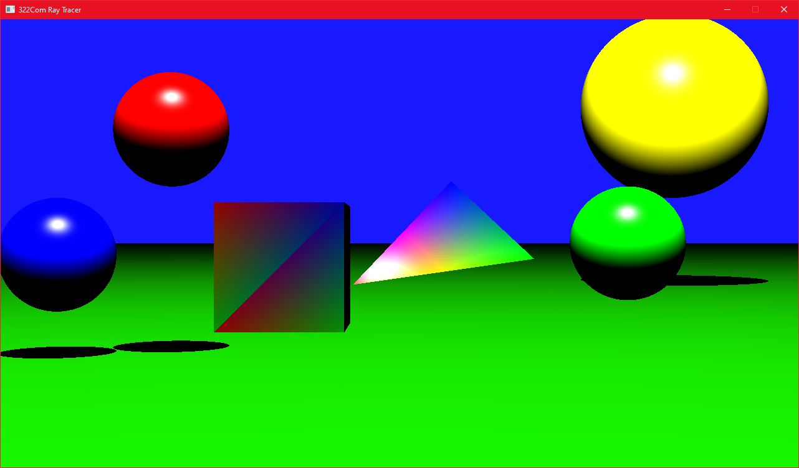

Figure 31 - Two lights

Figure 32 - One light

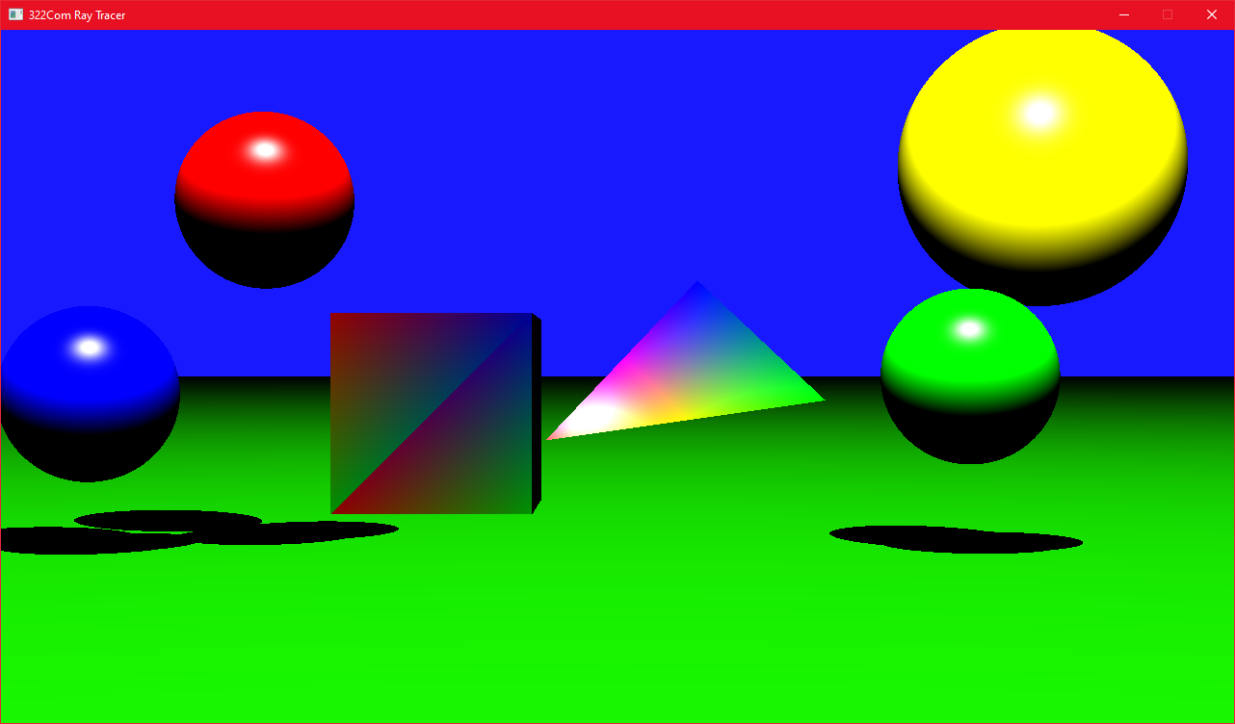

Figure 33 - Three lights

I can add as many primitives as I like to the scene, but due to the lack of multithreading performance really suffers. If I load in a complex OBJ model it can take a matter of minutes to load the scene. Using Release mode with compiler optimisations does help speed things up but there’s only so much you can do with one thread.

Conclusion

There are many features I wanted to add but ran out of time to do so, such as soft shadows, recursive reflection, and multi-threading. Multi-threading is a big loss as it currently my program is very slow, especially with multiple models/lights. I think the most difficult parts of this project for me were the loading of OBJs and shadow calculation. I ended up getting stuck on both features and had to spend time working out the problems, time I would have much rather spent adding more features. Given more time I would have liked to clean up the code and split parts of my main file into classes/functions to make the code easier to follow/modify. Having the code be a confusing mess makes it very hard to add new features/debug.

If I were to do this project again, I would make sure to brush up on my C++ skills first, as I had to waste time fixing issues that I wouldn’t have run into if I understood the C++ basics. I would also look into using Vulkan, which is GPU accelerated and very powerful.